### **Task: Configuring and Maintaining Office Software (Microsoft Word, PowerPoint, and Excel)**

##### **1. Verifying Installed Office Software:**

* Open each application and perform the following configurations:  
  
* 
* 

##### **2. Configuring Interface and Security Settings:**

**Microsoft Word, PowerPoint, and Excel: To configure interface and Settings they need subscription.**

**3. Performing Offline Maintenance**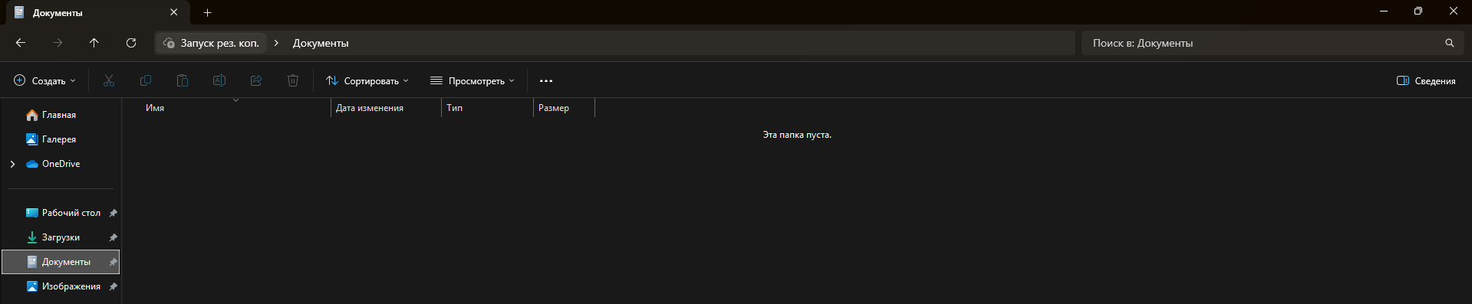

**Record:** What actions were taken to improve performance and security of the applications.

Although I won`t able to complete all the steps,I understand how they should work, their result action so, there are improved actions

* By cleaning up temporary files and unused templates, the overall performance of the applications was improved.
* Backing up user settings ensures that in case of future issues, custom settings can be restored.
* Ensuring proper security settings for macros and AutoSave helps prevent potential data loss and enhances document safety.

##### **4. Preparing a Report:**

**Application Versions: All application versions have been verified and confirmed to be up to date, ensuring optimal functionality.**

**Interface and Security Updates: Modifications were made to streamline the user interface for enhanced usability. Security settings were upgraded to bolster system protection and compliance.**

**Maintenance Activities: Routine maintenance tasks, including system diagnostics and performance tuning, were carried out successfully. The results show improved efficiency and stability across the system.**

**Challenges and Resolutions: Minor issues related to software compatibility were encountered and promptly addressed by updating the configuration settings.**